

**Green University of Bangladesh**

**Department of Computer Science and Engineering(CSE)**

**Faculty of Sciences and Engineering**

**Semester: (Spring, Year:2024), B.Sc. in CSE (Day)**

**LAB ASSIGNMENT NO #05**

**Course Title: Data Communication Lab**

**Course Code: CSE 308 Section: 221_D3**

**Lab Experiment Name: Implementing of Error Detection & Correction**

**Mechanism using Hamming Code**

**Student Details**

|  |  |  |
| --- | --- | --- |
| **Name** | | **ID** |
| **1.** | Jahidul Islam | 221002504 |

**Lab Date : 23 – 03 – 2024**

**Submission Date : 27 – 03 – 2024**

**Course Teacher’s Name : Sakhaouth Hossan**

**[For Teachers use only: Don’t Write Anything inside this box]**

|  |
| --- |
| **Lab Report Status**  **Marks: ………………………………… Signature:.....................**  **Comments:.............................................. Date:..............................** |

**1. TITLE OF THE LAB EXPERIMENT:**

**Implementing of** **Error Detection & Correction Mechanism using Hamming Code**

**2. OBJECTIVES:**

After complementing this lab experiment, we will gain practical knowledge and tthe outcomes of this experiment are

* To implement the Error Detection & Correction Mechanism using Hamming Code

**3. PROCEDURE:**

**Hamming Encoder Procedure:**

Inputs:

* Binary bit stream to be encoded.

Outputs:

* Encoded data with parity bits.

Procedure Steps:

1. **Prompt User**: Display a message to prompt the user to enter a binary bit stream.
2. **Input**: Accept the binary bit stream input from the user.
3. **Calculate Parity Bits**: Determine the number of parity bits required based on the length of the input data.
4. **Encode Data**:
   * Initialize an array to store the encoded data.
   * Initialize variables for tracking positions of data bits and parity bits.
   * Iterate over each position in the encoded data array:
     + If the position is a power of 2 (parity bit position), skip and increment the parity bit tracker.
     + Otherwise, copy the corresponding data bit from the input stream to the encoded data array and increment the data bit tracker.
5. **Calculate Parity Bits**:
   * For each parity bit position:
     + Calculate the parity by counting the number of '1's in specific combinations of data bits.
     + Set the parity bit to '1' if the count of '1's is odd, otherwise set it to '0'.
6. **Display Encoded Data**: Show the encoded data with parity bits to the user

**4. IMPLEMENTATION**

#include <iostream>

#include <string>

#include <cmath>

using namespace std;

int calculateParityBits(int m) {

int r = 0;

while (pow(2, r) < m + r + 1) {

r++;

}

return r;

}

string hammingEncode(const string& input) {

int m = input.length();

int r = calculateParityBits(m);

string encodedData(m + r, '0');

int p = 0;

int j = 0;

for (int i = 1; i <= m + r; i++) {

if (i == pow(2, p)) {

p++;

} else {

encodedData[i - 1] = input[j++];

}

}

for (int i = 0; i < r; i++) {

int parityIndex = pow(2, i) - 1;

int count = 0;

for (int j = parityIndex + 1; j <= m + r; j++) {

if ((j & (1 << i)) != 0) {

if (encodedData[j - 1] == '1') {

count++;

}

}

}

if (count % 2 != 0) {

encodedData[parityIndex] = '1';

}

}

return encodedData;

}

void displayBinaryString(const string& binaryString) {

for (char bit : binaryString) {

cout << bit << "";

}

cout << endl;

}

int main() {

string input;

cout << "Enter binary bit stream: ";

cin >> input;

string encodedData = hammingEncode(input);

cout << "Encoded data with parity bits: ";

displayBinaryString(encodedData);

return 0;

}

**5. OUTPUT**

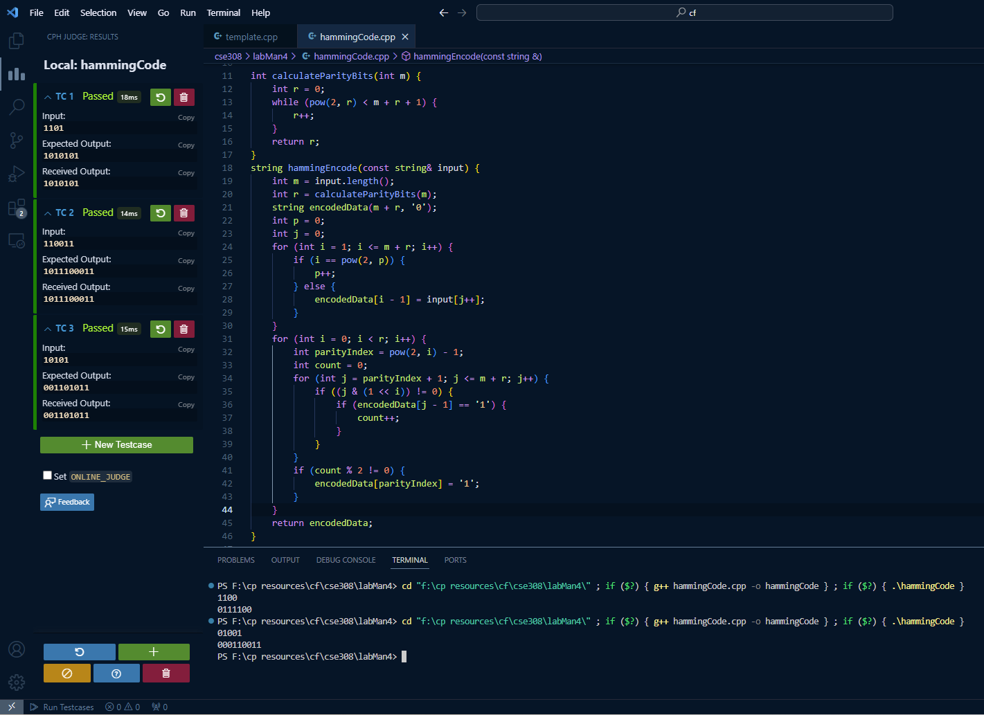

Figure 01: Shows the code and output of this code.

Figure 02: Output of the program.

**6. ANALYSIS AND DISCUSSION:**

**Hamming code is effective for single-bit error detection and correction but has limitations with multiple-bit errors.**